|  |  |  |
| --- | --- | --- |
| This exam paper must not be removed from the venue | Venue | ____________________ |
| Seat Number | __________ |
| Student Number | |__|__|__|__|__|__|__|__| |
| Family Name | ____________________ |
| First Name | ____________________ |

**School of Biological Sciences**

**EXAMINATION**

Semester One Examinations, 2022

**BIOL3360 Analysis & Communication of Biological Data**

*This paper is for St Lucia Campus and St Lucia Campus (External) students.*

|  |  |  |  |  |  |  |  |  |  |  |  |  |  |  |  |  |  |  |  |  |  |  |  |  |  |  |  |  |  |  |  |  |  |  |  |  |  |  |  |  |  |  |  |
| --- | --- | --- | --- | --- | --- | --- | --- | --- | --- | --- | --- | --- | --- | --- | --- | --- | --- | --- | --- | --- | --- | --- | --- | --- | --- | --- | --- | --- | --- | --- | --- | --- | --- | --- | --- | --- | --- | --- | --- | --- | --- | --- | --- |
| Examination Duration: 90 minutes  Reading Time: 10 minutes  **Exam Conditions:**  Learn.UQ invigilated  File upload to Turnitin  This is an Open Book examination  During Reading/Planning Time - Students are encouraged to review and plan responses to the exam questions  **Materials Permitted In The Exam Venue:**  Personal laptop  **Materials To Be Supplied To Students:**  None  **Instructions To Students:**  none | **For Examiner Use Only**   |  |  | | --- | --- | | Question | Mark | |  |  | |  |  | |  |  | |  |  | |  |  | |  |  | |  |  | |  |  | |  |  | |  |  | |  |  | |  |  | |  |  | |  |  | |  |  | |  |  | |  |  | |  |  | |  |  | |  |  |   Total _________ |

**Question 1: Write a function using R**

A plant biologist has a large data set on the morphology of 5 different species of eucalypt. Species were labelled in the data set as "Species1", "Species2", "Species3", "Species4", "Species5". Measurements of trunk diameter and canopy height were recorded. There were 25 specimens measured for each species. The plant biologist was interested in the relationship between trunk diameter and canopy height for each species. For one species, they used a simple linear regression, fitted by ordinary least-squares (OLS), using the following code:

fit <- lm(Canopy.Height ~ Trunk.Diameter, data = dat, subset=Species=="Species1") summary(fit)

**Write an R function** to perform separate linear regressions for all 5 eucalypt species. Write it so that the code is clearly communicated in order that a person unfamiliar with the code knows its purpose and can maintain and edit it.

(5 marks)

**Question 2: Create a data plot using R**

*Pseudemoia spenceri* is a small, arboreal skink found in highland areas from the Blue Mountains in NSW down to Victoria. A researcher was interested in determining whether the numbers of skinks was related to the diameter of trees on quadrats. At each of 5 sites, they measured the mean diameter (at breast height) of trees in 20 quadrats, and also counted the number of skinks in each quadrat. The data are available in the file “SkinkDat.csv.” Use R for your analyses.

Fit a Generalised linear Mixed-effect Model to the data, allowing a random intercept term for each site. **Show your code and output**.

(5 marks)

**Question 3: Format a figure for publication**

Convert the data plot from Question 2 above into an appropriately formatted figure, with caption, suitable for publication in a scientific journal. To format the figure you may use either R or another software e.g., MS Excel. (4 marks)

**Question 4: Explain an analysis to other scientists**

Write an explanation about how a generalized linear mixed-effects model in question 2 above was conducted. The explanation should be accurate and suitable for inclusion in a scientific paper (6 marks)

**Question 5: Write the biological story**

Using the output from question 2 above, write one or two sentences that communicates the necessary results of this analysis for inclusion in a scientific paper. (4 marks)

TIP - Remember to tell the biological story, you may need to attempt more than one draft of your sentences

**Question 6: Explain an analysis to other scientists – drop bears**

A scientist conducted the following study using a generalized linear model. Write an explanation about how the analysis was done (assuming it was conducted following the correct procedures) so that it is suitable for publication in a scientific paper. (6 marks)

Context for the study:

“Drop Bears (*Thylarctos plummetus*) are an arboreal carnivorous relative of the Koala, and are known to be a threat to humans in regions regularly visited by overseas tourists. In what follows, variables are in UPPER CASE.

An intrepid (and fool-hardy) BIOL3360 student intends to survey 50 sites (SITE) in southeast Queensland, each 100 m x 100 m, for the presence or absence of Drop Bears and record aspects of their habitat in order to better predict the presence of Drop Bears so the sites can be more safely managed for tourism. The student records the following variables: the presence or absence of Drop Bears (DROPBEARS), the number of mature Eucalyptus trees at each site (TREES), the diameter at breast height of the largest tree at each site (DBH), the distance to the nearest tourist barbeque area in metres (BBQ), the aspect of the site in degrees from North (ASPECT), and the elevation of the site in metres (ELEVATION).”

**Question 7: Write the biological story – drop bears**

Below is some of the output of the analysis of the drop bear sighting data described above. **Identify** the results in the information below and **write** them in one or two sentences to correctly communicate the results of this analysis for inclusion in a scientific paper. (4 marks)

TIP - Remember to tell the biological story, you may need to attempt more than one draft of your sentences

The researchers fit the following gls model, with the time-series effect grouped by SITE, and an autoregression of order 1:

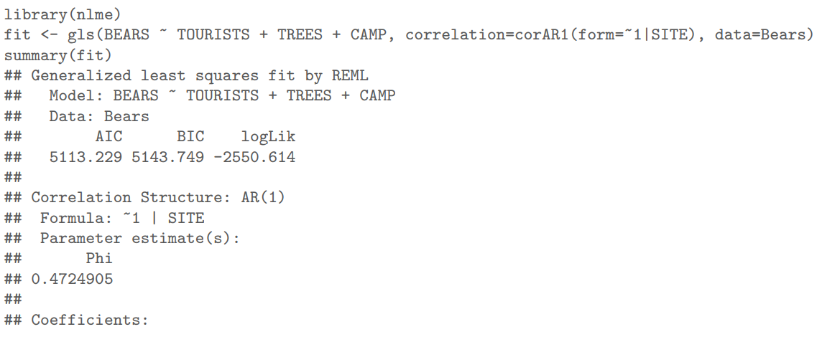

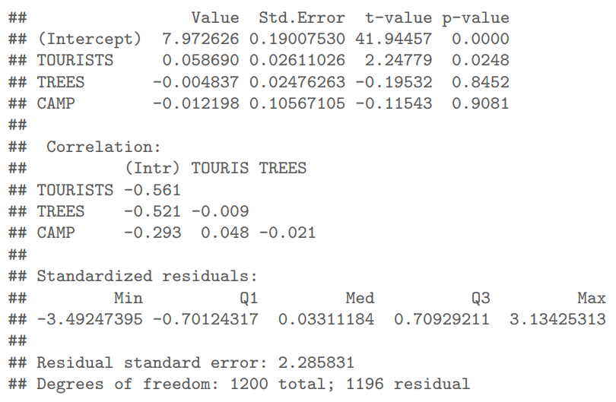

Below is the plot if the autocorrelogram of the residuals from the gls fit:

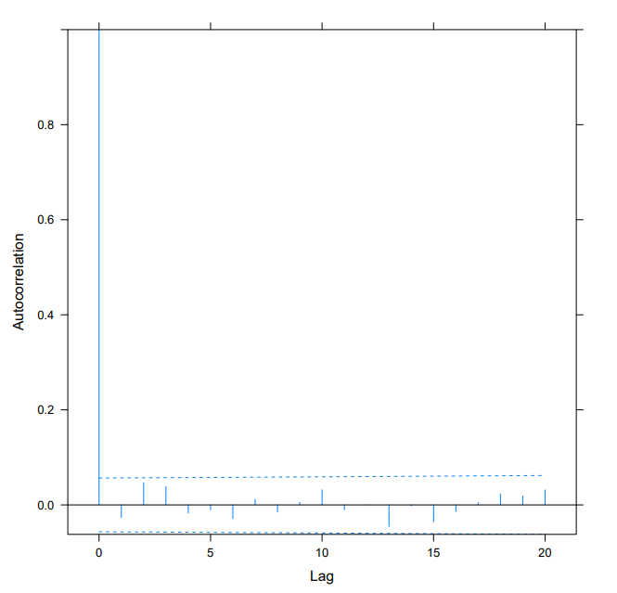

The researcher then produced the following ANOVA table for the analysis:

**Question 8: Communication conventions**

Most scientific papers follow the conventional format of abstract, introduction, methods, results, discussion. Thinking about the acronym **G.A.P.**, justify **how** and **why** you would change this format for the CEO of Sullivan and Nicolaides (a diagnostic pathology laboratory business, managed by medically trained professionals). In your answer indicate what you would **emphasise or add** to meet the priorities and interests of this audience. (6 marks)

**END OF EXAMINATION**